1. In mockup diagram

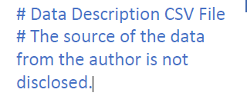

Proposed change?

# Data Description CSV Files

# Training.csv

# Testing.csv

1. In mockup diagram

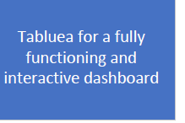

Proposed change

Tableua

1. In mockup diagram – We discussed limiting the number of questions to answer. I think it would be very complicated to train the model to specify gender or age based on the data so I propose removing it. I don’t think we need machine learning to answer what the most common disease is so I also propose removing it.

